1). Execute the script shown in the video.
main.tf
resource "aws_instance" "aws" {
ami = var.ami
instance_type = "t2.small"
tags = {
Name = "Module Instance"
}
}

variable "ami" {
}

main.dev
module "dev_ami"{
source = "../aws_instance"
ami = "ami-041607313c6a2a618"
}

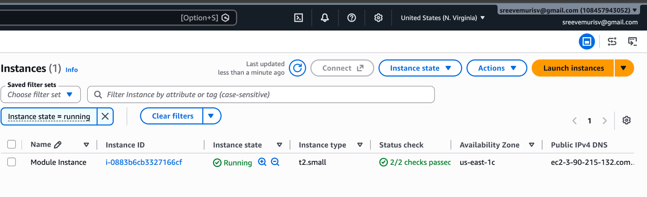

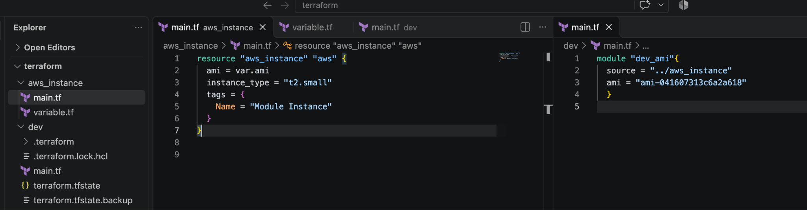
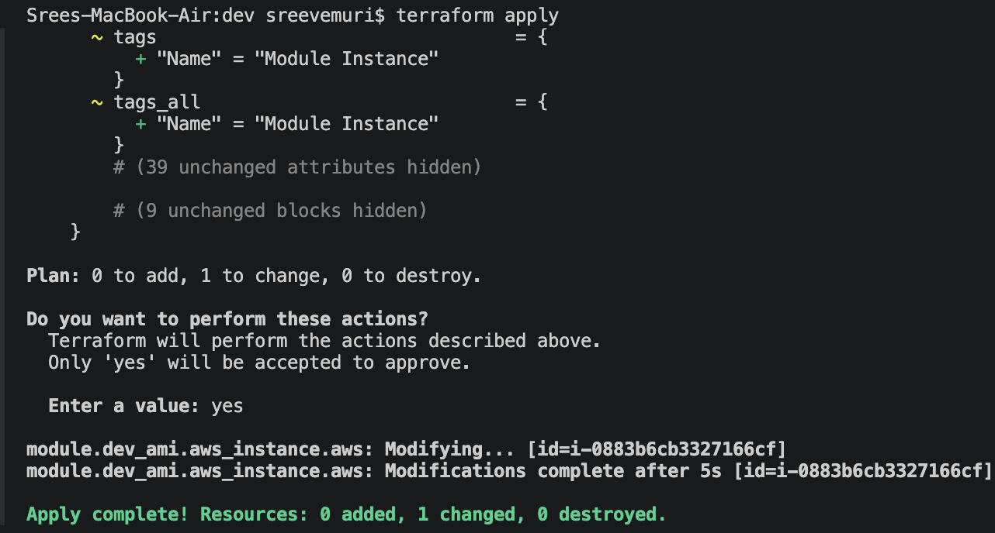

Workspace
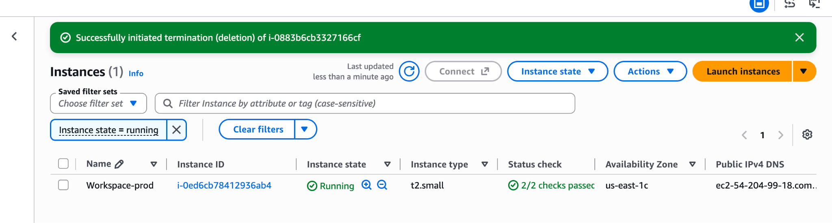

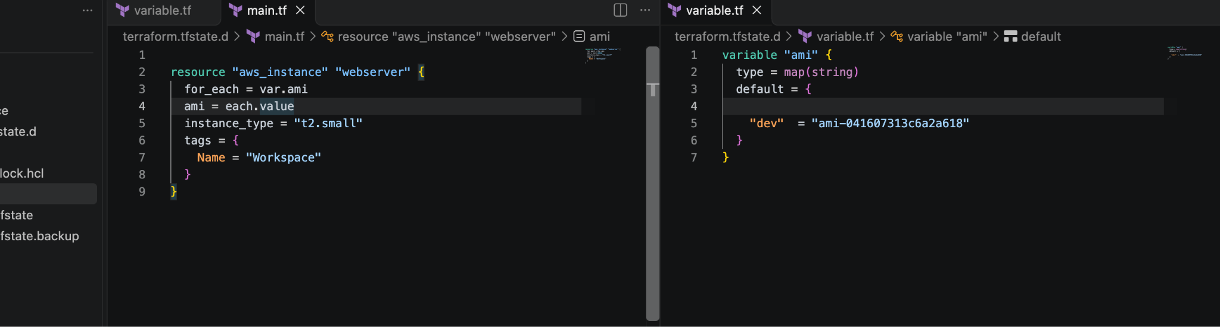

3). Provision EC2, S3, and VPC using Terraform modules.

Comprehensive Technical Documentation: Multi-Environment Terraform Infrastructure with Workspaces & Modules

1. Project Overview
This project provisions a modular, multi-environment cloud infrastructure on AWS using HashiCorp Terraform. It establishes an isolated Network topology (VPC, Subnet, Internet Gateway, Route Table), an object storage layer (S3 Bucket), and a compute tier (EC2 Instance) dynamically scaled across three environments (dev, staging, and prod) via Terraform Workspaces.

2. Project Directory Structure
terraform/
├── .terraform/
├── mo/
│ └── ec2/
│ ├── main.tf
│ ├── output.tf
│ └── variable.tf
├── module/
│ └── s3/
│ ├── main.tf
│ ├── output.tf
│ └── variable.tf
├── modules/
│ └── VPC/
│ ├── main.tf
│ ├── output.tf
│ └── variable.tf
├── providers.tf
└── root.tf

3. Module Breakdown & Configurations

A. VPC Module (modules/VPC/)
Responsible for provisioning network isolation, routing, and public internet access.
main.tf
resource "aws_vpc" "main" {
cidr_block = var.vpc_cidr
enable_dns_hostnames = true
enable_dns_support = true

tags = {
Name = "${var.environment}-vpc"
}
}

resource "aws_subnet" "public" {
vpc_id = aws_vpc.main.id
cidr_block = var.subnet_cidr
map_public_ip_on_launch = true

tags = {
Name = "${var.environment}-public-subnet"
}
}

resource "aws_internet_gateway" "igw" {
vpc_id = aws_vpc.main.id

tags = {
Name = "${var.environment}-igw"
}
}

resource "aws_route_table" "public" {
vpc_id = aws_vpc.main.id

route {
cidr_block = "0.0.0.0/0"
gateway_id = aws_internet_gateway.igw.id
}

tags = {
Name = "${var.environment}-public-rt"
}
}

resource "aws_route_table_association" "public" {
subnet_id = aws_subnet.public.id
route_table_id = aws_route_table.public.id
}

variable.tf
variable "vpc_cidr" { type = string }
variable "subnet_cidr" { type = string }
variable "environment" { type = string }

output.tf
output "vpc_id" { value = aws_vpc.main.id }
output "subnet_id" { value = aws_subnet.public.id }

B. S3 Module (module/s3/)
Provisions isolated object storage buckets tagged dynamically per environment.
main.tf
resource "aws_s3_bucket" "bucket" {
bucket = var.bucket_name

tags = {
Environment = var.environment
}
}

variable.tf
variable "bucket_name" { type = string }
variable "environment" { type = string }

output.tf
output "bucket_id" { value = aws_s3_bucket.bucket.id }

C. EC2 Module (mo/ec2/)
Manages compute resources linked directly to the provisioned public subnet.
main.tf
resource "aws_instance" "web" {
ami = var.ami_id
instance_type = var.instance_type
subnet_id = var.subnet_id

tags = {
Name = "${var.environment}-ec2-instance"
}
}

variable.tf
variable "ami_id" { type = string }
variable "instance_type" { type = string }
variable "subnet_id" { type = string }
variable "environment" { type = string }

output.tf
output "instance_id" { value = aws_instance.web.id }
output "public_ip" { value = aws_instance.web.public_ip }

4. Root Layer Orchestration

A. Provider Configuration (providers.tf)
terraform {
required_version = ">= 1.0.0"
required_providers {
aws = {
source = "hashicorp/aws"
version = "~> 5.0"
}
}
}

provider "aws" {
region = "us-east-1"
}

B. Root Orchestrator & Workspace Binding (root.tf)
This file reads terraform.workspace dynamically to look up environment-specific parameters without code duplication.
locals {
environment = terraform.workspace

instance_type = {
dev = "t2.micro"
staging = "t2.micro"
prod = "t2.small"
}

vpc_cidr = {
dev = "10.10.0.0/16"
staging = "10.20.0.0/16"
prod = "10.30.0.0/16"
}

subnet_cidr = {
dev = "10.10.1.0/24"
staging = "10.20.1.0/24"
prod = "10.30.1.0/24"
}
}

module "vpc" {
source = "./modules/VPC"
environment = local.environment
vpc_cidr = local.vpc_cidr[local.environment]
subnet_cidr = local.subnet_cidr[local.environment]
}

module "s3" {
source = "./module/s3"
environment = local.environment
bucket_name = "my-app-data-${local.environment}-981273"
}

module "ec2" {
source = "./mo/ec2"
environment = local.environment
ami_id = "ami-041607313c6a2a618" # Valid regional x86_64 AMI[span_0](start_span)[span_0](end_span)
instance_type = local.instance_type[local.environment]
subnet_id = module.vpc.subnet_id
}

5. Step-by-Step Execution Workflow
Initialize Working Directory Downloads required providers and links module local paths.
terraform init

Manage Environments via Workspaces Create independent state containers for your target environments:
terraform workspace new dev
terraform workspace new staging
terraform workspace new prod

- Switch & Deploy Specific Environments
Staging Deployment:
terraform workspace select staging
terraform plan
terraform apply -auto-approve

Development/Production Deployment:
terraform workspace select dev # or prod
terraform plan
terraform apply -auto-approve

6. Architectural Linking Breakdown
- Workspace Linkage: terraform.workspace captures the active state name (dev, staging, or prod) and acts as a lookup key for local variables (local.vpc_cidr[local.environment]). This separates infrastructure states inside .terraform/environment/.
- Module Output-Input Interlock: The root configuration captures attributes from the network tier (module.vpc.subnet_id) and passes them dynamically down to the compute tier (subnet_id = module.vpc.subnet_id), guaranteeing correct resource creation sequencing.

4). Provision EC2 for 3 different environments (Dev, Staging, and Prod) using Terraform workspaces.
Aim
To provision and scale EC2 instances dynamically across three distinct environments (dev, staging, and prod) using HashiCorp Terraform Workspaces and reusable modules.

Requirements
- Terraform CLI installed on your local machine.
- AWS Credentials configured (aws configure) with permissions to create EC2 instances and VPC resources.
- Project Structure:
  - An EC2 module directory (mo/ec2/) containing main.tf, variable.tf, and output.tf.
  - A root orchestrator file (root.tf) containing workspace configurations.

Steps to Follow

Step 1: Configure the EC2 Module (mo/ec2/main.tf)
Define the EC2 resource template with dynamic tagging and variable inputs:
resource "aws_instance" "web" {
ami = var.ami_id
instance_type = var.instance_type
subnet_id = var.subnet_id

tags = {
Name = "${var.environment}-ec2-instance"
}
}

Step 2: Configure Workspace Mapping in Root (root.tf)
Use terraform.workspace combined with local maps to provision different instance sizes per environment:
locals {
environment = terraform.workspace

instance_type = {
dev = "t2.micro"
staging = "t2.micro"
prod = "t2.small"
}
}

module "ec2" {
source = "./mo/ec2"
environment = local.environment
ami_id = "ami-041607313c6a2a618" # Valid regional AMI[span_0](start_span)[span_0](end_span)
instance_type = local.instance_type[local.environment]
subnet_id = module.vpc.subnet_id
}

Step 3: Initialize Terraform
Run initialization in your root directory:
terraform init

Step 4: Create and Deploy Across Workspaces
Run the deployment workflow sequentially for each environment:
Development Environment (dev):
terraform workspace new dev || terraform workspace select dev
terraform apply -auto-approve

Staging Environment (staging):
terraform workspace new staging || terraform workspace select staging
terraform apply -auto-approve

Production Environment (prod):
terraform workspace new prod || terraform workspace select prod
terraform apply -auto-approve

Where to Check the Output
- AWS EC2 Console:
  - Navigate to the EC2 Dashboard > Instances.
  - Look for the instance Name tags corresponding to your workspaces: dev-ec2-instance, staging-ec2-instance, and prod-ec2-instance.
- Terminal Output:
  - Terraform will print outputs (such as instance_id and public_ip) directly in your terminal upon successful completion of terraform apply.
- State Isolation (.terraform/):
  - Check your local project folder under .terraform/environment/ to confirm separate state containers exist for dev, staging, and prod.

Conclusion
By utilizing Terraform Workspaces alongside modular architecture, you successfully automated multi-environment provisioning. A single codebase dynamically configures isolated EC2 infrastructure with environment-specific sizing and tagging without code duplication.

